Chapter 2, Solution 82

The pin diagram of a resistance array is shown in Fig. 2.141. Find the equivalent resistance between the following:

(a) 1 and 2 (b) 1 and 3 (c) 1 and 4

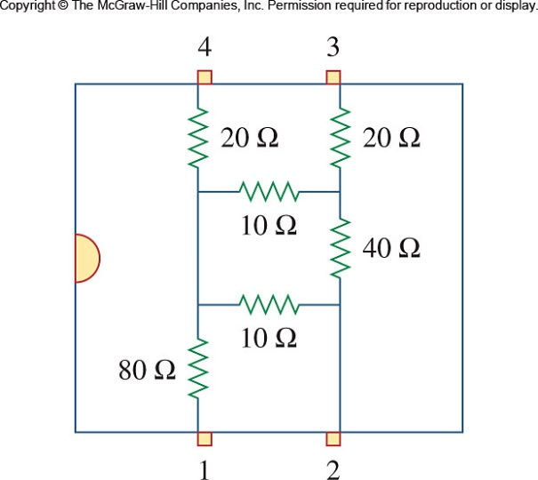

Figure 2.141
For Prob. 2.82.

Solution

(a)

10 Ω

40 Ω

10 Ω

R₁₂

80 Ω

2

1

R₁₂ = 80 + 88.33 Ω

(b)

20 Ω

40 Ω

80 Ω

3

1

R₁₃

10 Ω

10 Ω

R₁₃ = 80 + 108.33 Ω

20 Ω

40 Ω

80 Ω

4

1

R₁₄

10 Ω

10 Ω
(c)

R₁₄ = 100 Ω

